Max substring without repeating characters
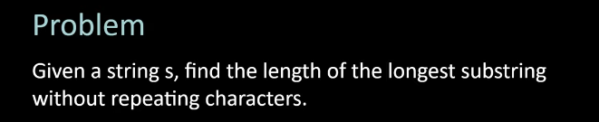
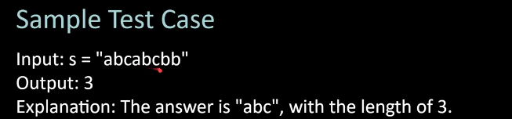
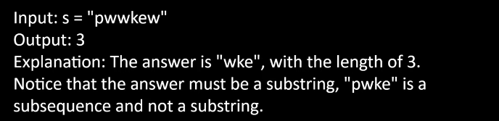
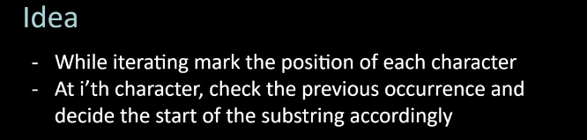

i/p
pwwkew

o/p
3

#include<bits/stdc++.h>
using namespace std;

int main(){
string s;
cin>>s;
int n=s.size();
int start=-1, maxLen=0;
vector<int>dict(256,-1);

for(int i=0 ;i<n ; i++){
if(dict[s[i]]> start){
start=dict[s[i]];
}
dict[s[i]]=i;
maxLen=max(maxLen,i-start);
}
cout<<maxLen;

}

